**BRIEF REPORT**

How many months ago did you last see your gastroenterologist? 3

**IBD ACTIVITY – CDAI/UCDAI**

|  |  |
| --- | --- |
| **Condition:** |  |
| Number of **years diagnosed** with IBD? |  |
| In the past 3 months my IBD has been: |  |
| Over the past week, how **many bowel movements have you had on average per day**? |  |
| Over the past week, how many of your bowel movements have been **loose/watery stools on average per day?** |  |
| General well-being over the last week: |  |
| Over the past week, my **rectal bleeding has been:** |  |
| Over the past week have you **taken any antidiarrheal medication?** |  |
| Have you experienced a **fever** over the past week? |  |
| Have you experienced an **abdominal mass/tenderness** over the last week? |  |
| Have you experienced **abdominal pain or cramping** over the last week? |  |
| Please tick any **complications** you are currently experiencing. |  |

**IBD ACTIVITY –**

**HOW DO THEY COMPARE TO THE LAST APPOINTMENT**

|  |  |
| --- | --- |
| Compared to your last visit to the gastroenterologist, how would you describe the status of your IBD **SYMPTOMS** now? |  |
| Compared to your last visit to the gastroenterologist, how would you describe the status of your **PAIN** now? |  |
| Compared to your last visit to the gastroenterologist, how would you describe any changes to the **FREQUENCY OF BOWEL MOVEMENTS** now? |  |

**MEDICATIONS**

|  |  |
| --- | --- |
| **Drug** | **Dosage:** |
|  |  |
|  |  |
|  |  |
|  |  |
| **Other medications:** | |

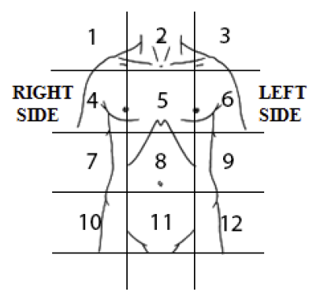 **PAIN SYMPTOMS**

|  |  |  |  |
| --- | --- | --- | --- |
| Location | Form of pain: | Duration of pain in last 24 hours | Rating of pain  (higher score  greater severity) |
|  |  |  |  |
|  |  |  |  |
|  |  |  |  |
|  |  |  |  |

**Patient questions/concerns**

|  |  |
| --- | --- |
| **Patient would like to talk about:** |  |

**MENTAL HEALTH**

|  |  |
| --- | --- |
| Do you consider **hurting yourself, others, or feel suicidal?** |  |
| Are you currently are **CURRENTLY seeing a mental health professional?** |  |
| Do you have an appointment with a mental health expert within the next 14 days or willing to contact your local doctor (GP) if your mental health symptoms worsen? |  |
| K10 SCORE |  |

**K10 SCORE INTERPRETATION:**

10-15 (Normal): Individuals tend to report minimal levels of psychological distress.

16-30 (Mild-moderate distress): Individuals tend to report some symptoms which may be associated with psychological distress.

31-50 (Severe distress): Individuals tend to report strong and frequent symptoms which may be associated with psychological distress.